

YENEPOYA INSTITUTE OF ARTS SCIENCE COMMERCE AND MANAGEMENT
A CONSTITUENT UNIT OF YENEPOYA (DEEMED TO BE UNIVERSITY)
BALMATTA, MANGALORE

A PROJECT REPORT ON
CLOUD COST INTELLIGENCE PLATFORM FOR SUPPLY CHAIN

SUBMITTED BY
SAYOOJ V
III BCA
(ARTIFICIAL INTELLIGENCE, CLOUD COMPUTING AND DEVOPS)
23BCAICD096

UNDER THE GUIDANCE OF
MS. DEEKSHA SHETTY
ASSISTANT PROFESSOR
DEPARTMENT OF COMPUTER SCIENCE
IN PARTIAL FULFILLMENT OF THE REQUIREMENT FOR THE AWARD
OF THE DEGREE OF
BACHELOR OF COMPUTER APPLICATIONS
MAY 2026

PROJECT REPORT
ON
SERVERLESS ARCHITECTURE FOR FINANCE SCALABILITY

Under the guidance of
Ms. Deeksha Shetty
Assistant Professor
Department of Computer Science

Submitted by
Sayooj v
23BCAICD096

BACHELOR OF COMPUTER APPLICATIONS
(AI, CLOUD COMPUTING & DEVOPS)



YENEPOYA INSTITUTE OF ARTS, SCIENCE, COMMERCE & MANAGEMENT
(A constituent unit of Yenepoya Deemed to be University) Balmatta, Mangaluru, Karnataka, India

CERTIFICATE

This is to certify that the project work entitled “Serverless Architecture For Finance Scalability” has been successfully carried out at “IBM Technology Company” by Sayooj V (Reg. No. 23BCAICD096), student of 3rd Year BCA (AI, Cloud Computing & DevOps), under the supervision and guidance of Ms .Deeksha Shetty, Faculty, Department of Computer Science, Yenepoya Institute of Arts, Science, Commerce and Management. This dissertation is submitted in partial fulfilment for the award of degree in Bachelor of Computer Applications by Yenepoya (Deemed to be university) during academic year 2023-26.

Internal Guide: Chairperson

Internal Examiner: External Examiner

PRINCIPAL
Dr. Jeevan Raj
The Yenepoya Institute of Arts,
Science, Commerce and Management
(Deemed To be university)

Submitted for the Viva-Voce Place :Mangalore

Examination held on: Date:

DECLARATION
I, Sayooj V, a student of BCA (Artificial Intelligence, Cloud Computing &
DevOps) at Yenepoya Institute of Arts, Science, Commerce and Management,
Balmatta, Mangalore, affiliated with Yenepoya (Deemed to be University), hereby
declare that this project report titled Serverless Architecture for Finance Scalability is a genuine and original record of the work undertaken by me as part of my
academic curriculum.

This report documents the knowledge, skills and practical experience acquired during my project at IBM Technology Company. It includes methodologies, analytical
processes and investigative approaches aligned with recognized industry standards
in digital forensics, incident response and cybersecurity investigations.

I extend my sincere gratitude to Mr. Sumit Kumar Shukla, IBM Program Head, for his valuable guidance, mentorship and support throughout the project period. I also express my appreciation to IBM Technology Company for providing an enriching environment and exposure to real-world cybersecurity operations.

Furthermore, I acknowledge the support and encouragement received from my institutional guide Ms. Deeksha Shetty, the faculty of Yenepoya Institute of Arts, Science, Commerce and Management. Their insights and assistance have been instrumental in successfully completing this project.

Intern Signature: | Institution Guide Signature:
Name: Sayooj V | Name: Ms. Deeksha Shetty
Date: | Institute: Yenepoya Institute of Arts, Science,Commerce and Management
IBM Supervisor Signature: | Date:
Name:Sumit Kumar Shukla | Head of the Department (HOD) Signature:
Designation: IBM Program Head | Name: Dr. Rathnakar Shetty P  Head of Department of Computer Science
Organization:  Date: | Institute: Yenepoya Institute of Arts,  Science, Commerce and Management  Date:

ACKNOWLEDGEMENT

I sincerely express my gratitude to Yenepoya Institute of Arts, Science, Commerce
and Management, affiliated with Yenepoya (Deemed to be University),
Mangalore, for providing me with the opportunity to undertake this project as part of my academic curriculum.
I extend my heartfelt thanks to Dr. Jeevan Raj, Principal, for his continuous support
and guidance in facilitating this learning opportunity. I also express my sincere
appreciation to Dr. Rathnakar Shetty P, Head of Department (Computer Science), for his encouragement and academic support throughout my project journey.

I am deeply grateful to Mr. Sumit Kumar Shukla and IBM Technology Company,
for their visionary leadership and for fostering a dynamic learning environment in
IBM Technology Program. A special note of appreciation goes to Mr. Sumit Kumar
Shukla, for his invaluable mentorship, expert guidance and for sharing his vast
experience in the field.

I am also thankful to my internal guide, Ms. Deeksha Shetty, for her academic mentorship and for providing valuable insights that helped bridge the gap between theoretical learning and practical application.
Lastly, I am grateful to my faculty mentors, family and peers for their encouragement
and motivation throughout this journey.

Name: Sayooj V
Reg NO: 23BCAICD096
Date:

Yenepoya Project Tracker - 2026
Task ID | Task Description | Project Title | Project  Time line | Start Date | End Date | Status | Feedback and  Comments
1 | -Selected project topic and understood requirements  -Installed tools: Python, VS Code, Postman, Docker | Serverless Architecture for Finance Scalability | Week 1  of 7 | 03  March  2026 | 09  March  2026 | Compl  eted | -Successfully completed environment setup  -Learned basics of FastAPI and APIs
2 | -Planned project structure and workflow  -Created GitHub repository and branches (main, develop) | Serverless Architecture for Finance Scalability | Week 2  of 7 | 10  March  2026 | 16  March  2026 | Compl  eted | -Improved understanding of GitHub workflow and project planning
3 | -Developed Income API (POST /income)  -Tested endpoint using Postman and Swagger UI | Serverless Architecture for Finance Scalability | Week 3  of 7 | 17  March  2026 | 23  March  2026 | Compl  eted | -Learned request handling and input validation using FastAPI
4 | -Developed Summary API and balance calculation logic  -Added in-memory data storage | Serverless Architecture for Finance Scalability | Week 4  of 7 | 24  March  2026 | 30  March  2026 | Compl  eted | - Improved understanding of backend logic and multiple endpoints
5 | -Developed Budget APIs and Health Check endpoint  -Added error handling for invalid inputs | Serverless Architecture for Finance Scalability | Week 5  of 7 | 31  March  2026 | 7  April  2026 | Compl  Eted | -Learned implementation of financial business logic and monitoring endpoints
6 | -Dockerized the application  -Performed testing using Postman and Swagger UI | Serverless Architecture for Finance Scalability | Week 6 of 7 | 8  April  2026 | 14  April  2026 | Compl  eted | -Learned Docker basics and API deployment concepts
7 | -Prepared final documentation and presentation  -Conducted final testing | Serverless Architecture for Finance Scalability | Week7 of 7 | 15  April  2026 | 22  April  2026 | Compl  eted | Project completed successfully with all required functionalities implemented

ABSTRACT

The Lightweight Finance API project is a backend application developed using Python and FastAPI to demonstrate the core concepts of API development and cloud-ready application design. The system allows users to manage financial information by providing endpoints to add income, expenses, and budget details, along with generating financial summaries and budget status reports. The application uses RESTful API principles and communicates through JSON-based requests and responses. Pydantic validation is implemented to ensure proper input handling and error management. The project also includes Docker containerization for portability and simplified deployment. Testing was performed using Swagger UI to verify the correctness of all endpoints. Currently, the application uses in-memory storage for simplicity and faster response handling, with future scope for integrating a database and authentication system. This project successfully demonstrates backend development concepts, request-response workflows, validation, and lightweight cloud computing practices in a professional finance context.

TABLE OF CONTENTS

SI No | Section Title | Page No
1 | Executive Summary | 1
2 | Background | 2
2.1 | Aim | 2
2.2 | Technologies | 2
2.3 | Hardware Architecture | 3
2.4 | Software Architecture | 3
3. | System | 9
3.1 | Requirements | 9
3.1.1 | Functional Requirements | 9
3.1.2 | User Requirements | 12
3.1.3 | Environmental Requirements | 14
3.2 | Design and Architecture | 16
3.3 | Implementation | 22
3.4 | Testing | 27
3.5 | Graphical User Interface (GUI) Layout | 33
3.6 | Customer Testing | 36
3.7 | Evaluation | 38
4. | Snapshots of the Project | 41
5. | Conclusions | 45
6. | Further Development or Research | 46
7. | References | 48
8. | Appendix | 49

1.EXECUTIVE SUMMARY

The Lightweight Finance API project is a backend-based financial management application developed using Python and FastAPI to demonstrate modern API development concepts in a cloud computing environment. The project was designed to provide a simple and efficient system for managing financial data such as income, expenses, and budget information through RESTful API endpoints. The application allows users to send requests and receive structured JSON responses instantly, making it lightweight, fast, and suitable for cloud-ready applications.

The system includes multiple endpoints for adding income, recording expenses, setting budgets, checking budget status, and generating financial summaries. FastAPI was selected as the development framework because of its high performance, automatic API documentation, input validation, and support for asynchronous operations. Pydantic models were implemented to validate request data and ensure reliable processing of user inputs. The application was tested using Postman and Swagger UI to verify the correctness and functionality of all endpoints.

The project also demonstrates professional software development practices such as GitHub version control, Docker containerization, API testing, and structured documentation including Proposal, High-Level Design (HLD), Low-Level Design (LLD), and Final Report preparation. Currently, the application uses in-memory data storage for simplicity and faster response handling, with future scope for database integration, authentication, and frontend development. Overall, the project successfully demonstrates backend API development, request-response workflows, validation mechanisms, and lightweight cloud computing practices in a professional finance context.

2. BACKGROUND
2.1 Aim
The main aim of the Lightweight Finance API project is to develop a simple and efficient backend application using Python and FastAPI that can manage financial data through RESTful API endpoints. The project focuses on implementing core backend functionalities such as adding income, recording expenses, setting budgets, and generating financial summaries. Another important objective of the project is to understand cloud computing workflows, request-response communication, JSON data handling, API validation, and lightweight application deployment using Docker. The system is designed to provide fast responses and demonstrate how modern backend services function in real-world financial applications.

2.2 Technologies
Sl No | Technology/Tool | Purpose
1 | python | Primary programming language used for backend development.
2 | FastAPI | Framework used to build high-performance REST APIs.
3 | Pydantic | Used for request validation and data handling.
4 | Swagger UI | Used for automatic API documentation and testing.
5 | Github | Used for version control and source code management.
6 | SourceTree | Used for Git branch and repository management.
7 | Docker | Used for containerization and environment consistency
8 | JSON | Used for request and response data exchange

2.3 Hardware Architecture
Sl no | Hardware Component | Specification / Purpose
1 | Processor | Intel/AMD Processor used for application execution and processing
2 | RAM | Minimum 4 GB RAM for running development tools and Docker containers
3 | Storage | SSD/HDD used for storing project files, Docker images, and source code
4 | System Type | Laptop/Desktop system used for local development and testing
5 | Internet Connection | Required for GitHub access, dependency installation, and Docker image download
6 | ClientDevice | Postman or Browser used to send API requests to the FastAPI server
7 | Local server | System hosting the FastAPI application during execution
8 | Operating System | Windows/Linux environment used for development and deployment

2.4 Software Architecture
Layered Architecture

The Lightweight Finance API project follows a simple layered software architecture based on the client-server model. The architecture is divided into multiple layers to ensure proper separation of responsibilities and smooth data processing.
Layer | Description
Client Layer | The client layer includes Postman, Swagger UI, or web browsers used to send API requests to the application.
API Layer | The API layer is developed using FastAPI and handles incoming HTTP requests and responses.
Business LogicLayer | This layer processes financial operations such as income addition, expense calculation, budget checking, and summary generation.
DataStorage Layer | The project currently uses in-memory Python lists to temporarily store financial data during application runtime.
Response Layer | Processed data is converted into JSON format and returned to the client as API responses.
Validation Layer | Pydantic models validate request data, ensuring correct data types and input structure before processing.

The first layer in the architecture is the Client Layer. This layer includes tools such as Postman, Swagger UI, and web browsers that are used by users to interact with the application. The client layer sends HTTP requests to the backend API and receives JSON responses generated by the system. Users can perform operations such as adding income, recording expenses, setting budgets, generating financial summaries, and checking API health status through this layer. The client layer acts as the interface between the user and the backend application.

The second layer is the API Layer, which is developed using FastAPI. This layer is responsible for handling incoming HTTP requests and generating appropriate responses. The FastAPI framework manages API routing, endpoint execution, request handling, and response processing. It supports RESTful API architecture and provides high performance, automatic API documentation, asynchronous request handling, and lightweight backend execution. The API layer serves as the core communication channel between the client and the backend processing components.

The Validation Layer is another important component of the software architecture. This layer uses Pydantic models to validate incoming request data before processing. It checks data types, required fields, and input structures to ensure that only valid and properly formatted data enters the system. Invalid or incomplete requests generate structured validation error responses, improving system reliability, stability, and data integrity. This validation mechanism prevents incorrect data from affecting backend processing and ensures consistent API behavior.

The Business Logic Layer acts as the main processing unit of the application. This layer performs all financial operations such as income addition, expense calculation, budget checking, financial summary generation, and balance computation. The business logic layer processes user requests after successful validation and ensures that all calculations and operations are executed accurately according to the application requirements. This layer represents the functional core of the Lightweight Finance API project and is responsible for implementing the actual financial management logic within the system.

The Data Storage Layer is responsible for temporarily storing financial data during application runtime. The current implementation uses in-memory Python lists and data structures instead of a database to maintain a lightweight and simplified architecture. Income details, expense records, and budget values are stored temporarily in memory while the application is running. This approach improves processing speed and simplifies implementation for educational and demonstration

purposes. The modular architecture also allows future integration of relational or cloud-based databases without major modifications to the existing system.

The final layer is the Response Layer, which converts processed data into structured JSON format and sends it back to the client as an API response. This layer ensures standardized communication between the backend system and client applications. The JSON responses may contain operation results, financial summaries, status messages, validation errors, or API health information. The structured response format improves readability, compatibility, and integration with modern web and cloud-based applications.
Data Flow: Client Request
↓
FastAPI Endpoint
↓
Pydantic Validation
↓
Business Logic Processing
↓
JSON Response

The above data flow diagram represents the movement of data and the sequence of operations performed within the Lightweight Finance API project during API request processing. The data flow architecture explains how information travels through different layers of the system, beginning from the client request and ending with the generation of a structured JSON response. This workflow demonstrates the internal functioning of the backend application and highlights the interaction between various components involved in request handling, validation, processing, and response generation.

The process begins when the client sends an HTTP request to the FastAPI application using tools such as Postman, Swagger UI, or a web browser. These requests may include financial operations such as adding income, recording

expenses, setting budgets, checking budget status, or generating financial summaries. The client communicates with the backend system using RESTful API methods such as GET and POST along with financial data provided in JSON format.

After receiving the request, the FastAPI endpoint processes the incoming request and routes it to the appropriate API function based on the requested operation. The FastAPI framework efficiently handles request routing, endpoint execution, and response management while maintaining lightweight and high-performance backend processing.

The next stage in the data flow is Pydantic Validation. At this stage, the system validates the request data using Pydantic models to ensure that all required fields, data types, and input formats are correct. The validation process prevents invalid, incomplete, or incorrectly formatted data from being processed by the application. If invalid data is detected, the system generates structured validation error responses and returns them to the client. This validation mechanism improves application reliability, data integrity, and system stability.

Once validation is completed successfully, the Business Logic Processing stage performs the required financial operations based on the client request. This includes calculations related to income management, expense tracking, budget monitoring, balance calculation, and financial summary generation. The business logic layer acts as the core processing unit of the application and ensures accurate handling and processing of financial data before generating the final response.

After completing the required processing operations, the application generates a structured JSON response containing operation results, status messages, financial summaries, validation information, or error details. The JSON response is then sent back to the client through the FastAPI application. The use of JSON-based communication ensures compatibility with RESTful API standards and enables efficient data exchange between the client and backend system.

The data flow architecture demonstrates the lightweight, modular, and efficient design of the application. The organized flow of data between different processing stages improves maintainability, simplifies debugging, enhances performance, and supports future scalability of the system. Overall, the data flow process ensures smooth communication, reliable validation handling, accurate financial processing, and efficient response generation within the Lightweight Finance API project.

3. SYSTEM

3.1 Requirements

3.1.1 Functional Requirements

Sl. No | Functional Requirement | Description
1 | Income Management | The system should allow users to add income details through API endpoints.
2 | Expense Management | The system should allow users to record expense details.
3 | Budget Management | The system should allow users to set and monitor budgets
4 | Financial Summary | The system should generate total income, expenses, and balance summary.
5 | Input Validation | The system should validate user inputs using Pydantic models.
6 | JSONResponse Handling | The system should return structured JSON responses for all API requests
7 | Health Check | The system should provide a health endpoint to verify API status.

The above functional requirements define the major operations and core functionalities implemented within the Lightweight Finance API project. These requirements describe the essential features that the system must perform to ensure proper financial data management, API processing, validation handling, and response generation. Functional requirements play an important role in guiding the development process because they help establish the expected behavior and operational capabilities of the application.

One of the primary functional requirements of the system is Income Management. The application should allow users to add and manage income-related details through dedicated API endpoints. Users can send income information such as amount and source details using HTTP requests, and the system processes and stores this information for financial calculations and summary generation.

Another important functionality is Expense Management. The system should allow users to record and manage expense-related information such as expense amount and expense category. This functionality helps track financial spending and contributes to balance calculation and budget monitoring operations within the application.

The Budget Management functionality enables users to set and monitor budget values using specific API endpoints. The system processes budget information and compares it with recorded expenses to calculate remaining balance and budget status. This feature supports financial planning and spending analysis within the application.

Financial Summary generation is another core requirement of the system. The application should calculate and generate summaries containing total income, total expenses, and remaining balance based on the available financial data. This functionality helps users understand their financial status and overall spending patterns through structured JSON responses.

Input Validation is implemented using Pydantic models to ensure that all incoming request data is properly verified before processing. The validation system checks required fields, data types, and input formats to prevent invalid or incomplete data from entering the application. This improves system reliability, stability, and data consistency.

The system also includes JSON Response Handling functionality, where all API responses are returned in a structured JSON format. JSON-based communication improves compatibility with RESTful API standards and allows efficient data exchange between the client and backend system. The structured responses help users clearly understand operation results, validation errors, and financial summaries.

Another important functional requirement is the Health Check feature. The system provides a dedicated health endpoint that allows users to verify whether the API service is running successfully.

This endpoint helps monitor backend availability and supports system testing and debugging activities during development and deployment.

Overall, these functional requirements collectively ensure that the Lightweight Finance API project operates as a reliable, lightweight, efficient, and user-friendly backend application capable of handling essential financial management operations and modern API processing workflows.

3.1.2 User Requirements

Sl.No | User Requirements | Description
1 | Easy API Access | Users should be able to access APIs using Postman or Swagger UI.
2 | Fast Response | The system should provide quick responses to API requests.
3 | Financial Tracking | Users should be able to manage income, expenses, and budgets easily.
4 | Error Handling | Users should receive proper error messages for invalid inputs.
5 | Simple Interface | The API documentation should be simple and understandable for testing purposes

The above user requirements define the expectations and needs of users interacting with the Lightweight Finance API project. These requirements focus on ensuring that the system remains simple, efficient, reliable, and user-friendly while performing financial management operations. Understanding user requirements is important because it helps design the application in a way that improves usability, accessibility, response handling, and overall user experience.

One of the primary user requirements is easy API access. Users should be able to interact with the API endpoints conveniently using tools such as Postman or Swagger UI. The system was designed to provide a straightforward and organized interface where users can easily send requests, enter financial data, and view API responses without requiring advanced technical knowledge. The automatically generated API documentation in Swagger UI further simplifies endpoint usage and testing.

Fast response handling is another important user requirement. The system should process incoming requests quickly and return accurate responses with minimal delay.

Since the project uses the FastAPI framework and lightweight backend architecture, the API delivers efficient request processing and real-time JSON response generation. This improves system performance and enhances the overall user experience during API interaction.

The application was also designed to support efficient financial tracking operations. Users should be able to manage income details, expense records, budgets, and financial summaries easily through dedicated API endpoints. The organized structure of the endpoints allows users to perform financial operations clearly and systematically while maintaining accurate data processing.

Proper error handling is another essential requirement addressed within the system. Users should receive meaningful and structured error messages whenever invalid or incomplete data is submitted. Input validation using Pydantic models ensures that incorrect requests are detected and appropriate validation errors are returned. This improves system reliability and helps users understand and correct mistakes during request submission.

The project also emphasizes a simple and understandable interface for API testing and interaction. The API documentation and endpoint layout were designed to remain clean, lightweight, and easy to navigate. This helps users understand request formats, endpoint functionalities, and response structures more effectively during testing and demonstration activities.

Overall, the user requirements helped shape the development of a lightweight, responsive, user-friendly, and reliable backend API system capable of handling financial operations efficiently while maintaining simplicity and ease of use.

3.1.3 Environmental Requirements

Environmental Requirement | Description
Operating System | Windows or Linux operating system environment
Programming Language | Python 3.x
Framework | FastAPI framework
Development Tool | Visual Studio Code (VS Code)
API Testing Tool | Postman and Swagger UI
Version Control | GitHub and SourceTree
Containerization Tool | Docker
Internet Connectivity | Required for package installation and GitHub access

The above environmental requirements represent the software and system environment necessary for the successful development, execution, testing, and deployment of the Lightweight Finance API project. These requirements ensure that the application functions correctly and provides a stable environment for backend API development and testing activities. Proper environmental setup is important because it directly affects application compatibility, performance, maintainability, and deployment consistency.

The project was developed using the Windows or Linux operating system environment, providing flexibility and compatibility across different platforms. Python 3.x was selected as the primary programming language because of its simplicity, readability, extensive library support, and strong compatibility with modern backend frameworks. The FastAPI framework was used to develop the RESTful API due to its high performance, lightweight architecture, automatic documentation generation, asynchronous request handling, and built-in validation support.

Visual Studio Code (VS Code) was used as the main development environment for writing, editing, debugging, and managing the source code. Its lightweight design, extension support, and integrated terminal improved development productivity and simplified project management. Postman and Swagger UI were used as API testing tools to send HTTP requests, verify responses, validate endpoints, and monitor API behavior during testing and implementation stages.

For version control and project management, GitHub and SourceTree were used to maintain source code history, manage branches, track project changes, and support structured development workflows. This improved project organization, collaboration, and backup management throughout development.

The project also used Docker as the containerization tool to package the application and its dependencies into a portable containerized environment. Docker improved deployment consistency, portability, environment isolation, and cloud readiness of the application. The Dockerized setup ensured that the application could run reliably across different systems without dependency conflicts or configuration issues.

Internet connectivity was required throughout the project for downloading Python packages, installing dependencies, accessing GitHub repositories, updating development tools, and downloading Docker images. It also supported project documentation access, package management, and online resource utilization during development and testing activities.

Overall, the environmental requirements provided a stable, lightweight, and professional development environment suitable for backend API implementation, testing, deployment, and future scalability of the Lightweight Finance API project.

3.2 Design and Architecture

3.2.1 Component Design

The Lightweight Finance API project is designed using multiple interconnected components that work together to process financial data efficiently and provide smooth communication between the client and the backend system. The architecture follows a simple and modular approach to ensure easy understanding, maintainability, scalability, and efficient request handling. Each component in the system performs a specific responsibility, allowing the application to remain organized and lightweight while supporting future enhancements and feature integration.

The client component allows users to interact with the system using Postman, Swagger UI, or a web browser by sending HTTP requests to the API endpoints. These requests include operations related to income management, expense tracking, budget management, and financial summary generation. The client layer acts as the interface between the user and the backend application, enabling users to test and monitor API responses easily.

The FastAPI application acts as the central processing unit of the system and handles all incoming API requests. It processes different HTTP methods such as GET and POST to perform the required financial operations. FastAPI was selected because of its high performance, lightweight architecture, automatic API documentation, and support for asynchronous processing. The framework efficiently manages routing, request handling, and response generation while maintaining fast execution speed.

The validation component uses Pydantic models to verify user input and ensure that only valid and properly formatted data is processed by the system. This validation mechanism helps prevent invalid requests, missing values, and incorrect data types

from entering the application. By implementing automatic validation, the system improves reliability, data consistency, and overall application stability.

After successful validation, the business logic component performs the required financial operations such as calculating total income, total expenses, remaining balance, and budget status. This layer contains the core processing logic of the application and is responsible for executing financial calculations based on user input. The logic component ensures that all operations are processed accurately before generating responses.

The processed financial data is temporarily stored using in-memory Python data structures, which allows fast access and lightweight processing during application runtime. Since the current project scope focuses on lightweight API development and backend workflows, in-memory storage was used instead of a database for simplicity and faster implementation.

However, the modular design allows future integration of relational or cloud-based databases without major architectural changes.

Finally, the response component converts the processed output into JSON format and sends it back to the client as an API response. The JSON-based response structure ensures compatibility with modern web applications and RESTful API standards.

This component-based design ensures simplicity, modularity, scalability, maintainability, and efficient backend processing within the application while demonstrating modern API development practices in a finance-related cloud computing environment.

3.2.2 Data Model
Data Entity | Attributes | Description
Income | amount, source | Stores,income-related details entered by the user.
Expense | amount, category | Stores expense-related  information.
Budget | amount | Stores,user-defined budget value.
Summary | total_income,total_expense, balance | Represents a calculated financial summary data.
Health Status | Indicates whether the API is running successfully. | Indicates whether the API is running successfully.

The above data model table represents the major data entities used within the Lightweight Finance API project for managing and processing financial information. Each entity in the system is designed to store and handle specific types of financial data required for API operations such as income tracking, expense management, budget calculation, summary generation, and system monitoring. The data model plays an important role in organizing application data and supporting smooth backend processing.

The Income entity is responsible for storing income-related information entered by the user, including the income amount and source details. This entity helps track financial earnings and contributes to summary calculations within the system. Similarly, the Expense entity stores expense-related information such as expense amount and category, allowing the application to record and process different types of financial expenditures accurately.

The Budget entity is used to store user-defined budget values, which are later utilized for budget monitoring and remaining balance calculations. This entity helps users manage financial planning and compare expenses against the available budget. The Summary entity represents calculated financial data including total income, total expenses, and remaining balance. This entity is generated dynamically by processing the stored income and expense information within the application.

The Health Status entity is used for monitoring the operational condition of the API service. It indicates whether the FastAPI application is running successfully and accessible during execution. This helps verify backend service availability and supports system monitoring during testing and deployment.

The data model follows a simple and lightweight structure suitable for backend API development and in-memory data handling. The organized arrangement of entities and attributes improves data processing efficiency, validation handling, maintainability, and future scalability of the application. The current model can also be extended easily in future versions to support database integration, user authentication, transaction history, and advanced financial management features.

3.2.3 Process Flow
Client Request
↓
FastAPI Endpoint
↓
Input Validation
↓
Business Logic
↓
JSON Response

The above process flow diagram represents the sequence of operations performed within the Lightweight Finance API project during request processing and response generation. The process flow explains how data moves through different stages of the backend application, starting from the client request and ending with the generation of a structured JSON response. This workflow demonstrates the internal functioning of the RESTful API architecture implemented using FastAPI.

The process begins when the client sends an HTTP request to the FastAPI application using tools such as Postman, Swagger UI, or a web browser. These requests may include financial operations such as adding income, recording expenses, setting budgets, checking budget status, or generating financial summaries. The client interacts with the backend system by sending requests using HTTP methods such as GET and POST along with the required financial data in JSON format.

After receiving the request, the FastAPI endpoint processes the incoming data and routes it to the appropriate API function based on the requested operation. Each endpoint is responsible for handling a specific financial activity such as income management, expense tracking, budget processing, or summary calculation. The FastAPI framework efficiently manages request routing and endpoint execution while maintaining fast response handling and lightweight application performance.

The input validation stage then verifies the request data using Pydantic models to ensure that all required fields, data types, and input formats are correct. This validation mechanism helps prevent invalid, incomplete, or incorrectly formatted data from entering the system. Validation improves overall application reliability, stability, and data consistency by ensuring that only valid requests are processed further. Appropriate validation error messages are returned whenever invalid input is detected.

Once the validation process is completed successfully, the business logic layer performs the required financial operations such as income calculation, expense processing, budget management, balance calculation, and summary generation. The

logic layer acts as the core processing component of the application and ensures accurate handling of financial data according to the user request. Different calculations and financial operations are executed within this stage before generating the final output.

After processing the request, the application generates a structured JSON response containing operation results, financial summaries, success messages, status information, or validation errors. The JSON response is then returned to the client through the FastAPI application. This response format follows RESTful API standards and ensures compatibility with modern web applications and backend systems.

The process flow ensures smooth communication between the client and backend system while maintaining efficient request handling, proper validation, accurate data processing, and fast response generation. Since the project uses a lightweight architecture with in-memory data storage, the request-response cycle remains fast and efficient during execution.

The process flow also demonstrates the working principle of modern RESTful API architectures where requests are validated, processed, and returned in a standardized format.

The lightweight and modular nature of the workflow improves system performance, simplifies debugging, enhances maintainability, and supports future scalability and feature enhancements within the application. This structured workflow plays an important role in ensuring the reliability, efficiency, and professional design of the Lightweight Finance API project.

3.3 Implementation
3.3.1 Project Structure

Lightweight-Finance-API/
│
├── app.py
├── requirements.txt
├── Dockerfile
├── docker-compose.yml
├── test_api.py
├── README.md
│
└── docs/
├── Proposal
├── HLD
├── LLD
└── Final Report

The above project structure represents the organized file and folder arrangement used for developing the Lightweight Finance API project. The structure was designed to maintain simplicity, readability, maintainability, scalability, and efficient project management throughout the development process. A clean and well-organized project structure is important in backend application development because it helps developers easily manage source code, testing files, deployment

configurations, and technical documentation without confusion. The structure also improves collaboration, debugging, future enhancements, and overall maintainability of the application.

Each file and directory within the project serves a specific purpose related to backend development, testing, deployment, and documentation management. The root directory contains all major files required for application execution and project configuration. The lightweight organization of the project ensures that the application remains easy to understand and suitable for academic demonstration as well as future scalability.

The app.py file acts as the central application file containing the FastAPI backend implementation, API routes, request handling logic, validation mechanisms, and response generation functionalities. All major API endpoints related to income management, expense tracking, budget handling, summary generation, and health monitoring are implemented within this file. The file also contains business logic for performing financial calculations and generating structured JSON responses. Since the project follows a lightweight architecture, maintaining the core application logic within a single file improved simplicity and reduced unnecessary complexity.

The requirements.txt file contains all required Python dependencies and external libraries needed for executing the project successfully. This file helps maintain environment consistency across different systems by ensuring that all required packages such as FastAPI, Pydantic, and Uvicorn are installed correctly. Using a dependency management file also simplifies project setup and deployment for other users and developers.

The Dockerfile is used for containerizing the application using Docker, allowing the API to run inside a lightweight and portable containerized environment. Containerization improves deployment consistency and ensures that the application runs reliably across different operating systems and environments. The docker-compose.yml file further simplifies Docker container execution and configuration

management by automating container startup and service management. These files collectively improve portability, deployment readiness, and cloud compatibility of the application.

The test_api.py file is used for API testing and validation purposes. It helps verify endpoint functionality, response handling, request processing, and API behavior during development and testing stages. Through this file, different test cases can be executed to confirm correct API operation and identify potential issues during implementation. Testing files improve application reliability and help maintain stable functionality throughout development.

The README.md file contains important project-related information such as project overview, objectives, installation instructions, execution steps, API endpoint details, Docker commands, and usage guidelines. This documentation improves usability and allows users, evaluators, and developers to understand the project workflow and setup process easily. Proper documentation is essential in professional software development because it improves maintainability and simplifies project understanding.

The docs folder is dedicated to storing all technical and academic project documentation including the Proposal, High-Level Design (HLD), Low-Level Design (LLD), and Final Report. Organizing documentation within a separate folder improves file management and ensures that all important project reports remain structured, accessible, and easy to maintain. This approach also supports professional documentation practices followed in software engineering projects.

Overall, the project structure follows a clean, modular, lightweight, and organized development approach that simplifies backend implementation, testing, debugging, deployment, and documentation management. The structure improves readability, maintainability, portability, and scalability while ensuring that the application remains simple enough for academic evaluation and future expansion. The organized arrangement of files and folders also demonstrates good software engineering

practices and contributes to the overall professionalism of the Lightweight Finance API project.

Since the files are organized clearly and logically, developers and evaluators can quickly understand the workflow and architecture of the system without unnecessary complexity.

The lightweight arrangement also reduces development overhead and minimizes dependency management issues during implementation and testing.

3.3.2 Module Implementation Details

Income Module

The Income module is responsible for handling income-related operations. It allows users to add income details through the POST /income endpoint.
The module validates user input using Pydantic models and stores the income data temporarily in memory.

Expense Module

The Expense module manages expense-related operations. It provides the POST /expense endpoint for recording expenses and processes the financial data for expense tracking and calculations.

Budget Module

The Budget module allows users to set and manage budget values using the POST /budget endpoint. It also supports monitoring remaining budget through the GET /budget-status endpoint.

Summary Module

The Summary module calculates financial summaries using the GET /summary endpoint. It generates total income, total expenses, and balance information based on the stored data.

Health Check Module

The Health Check module provides the GET /health endpoint to verify whether the API service is running properly. It is mainly used for monitoring and debugging purposes.

Validation Module

The Validation module uses Pydantic models to validate request data and ensure proper input formatting before processing any financial operations.

3.4 Testing

3.4.1 Testing Strategy

The Lightweight Finance API project was tested using both manual API testing and functional validation techniques to ensure the correctness, reliability, stability, and performance of all implemented endpoints. The testing process was conducted continuously during different stages of development to identify errors, verify endpoint functionality, validate request-response handling, and improve overall system reliability. Since the project is based on RESTful API architecture, testing was considered an essential part of development to ensure that the backend services processed financial data accurately and returned proper JSON responses under different conditions.

Postman and Swagger UI were used as the primary testing tools to send HTTP requests and verify API responses. Swagger UI provided an automatically generated interactive web-based interface through FastAPI, allowing direct endpoint execution and response verification from the browser itself. Postman was used extensively for advanced API testing because it allowed sending custom request payloads, modifying request headers, and testing multiple scenarios efficiently. These tools helped verify endpoint behavior, response accuracy, request validation, and API stability.

Each API endpoint was tested with both valid and invalid inputs to ensure correct request handling, response generation, validation processing, and proper error handling. The testing process included verifying HTTP methods such as GET and POST, checking status codes, and confirming that all responses were returned in

proper JSON format. Functional testing ensured that each endpoint performed its intended operation correctly without affecting other modules in the application.

The testing strategy mainly focused on validating core functionalities such as income management, expense tracking, budget calculation, financial summary generation, and API health monitoring. The `POST /income` endpoint was tested using different income values and sources to ensure successful data handling and storage. Similarly, the `POST /expense` endpoint was tested with multiple expense categories and amounts to confirm correct expense recording functionality. Budget-related endpoints were tested to verify accurate budget calculations, remaining balance computation, and budget status monitoring.

The `GET /summary` endpoint was tested thoroughly to confirm correct calculation of total income, total expenses, and remaining balance based on the stored financial data. Multiple combinations of income and expense values were tested to verify calculation accuracy and consistency of financial summaries. The Health Check endpoint (`GET /health`) was also tested repeatedly to confirm that the API service remained active and accessible throughout execution.

Input validation testing was performed using Pydantic models to ensure that incorrect, missing, negative, or improperly formatted data produced appropriate validation error responses. Different edge cases such as empty fields, invalid data types, null values, and incorrect request structures were tested to evaluate the robustness and reliability of the validation mechanism. Proper HTTP response codes such as `200 OK`, `400 Bad Request`, and `422 Validation Error` were verified to ensure consistent API behavior and user-friendly error handling.

Error handling tests were also performed to verify system stability under unexpected conditions. Invalid API requests were intentionally sent to confirm that the application returned meaningful error messages without crashing or affecting other endpoints. This helped improve the reliability and fault tolerance of the system.

Performance testing was conducted by executing repeated API requests to observe response speed and system behavior during continuous operation. Since the application uses FastAPI, the API demonstrated quick response handling and lightweight execution even during repeated testing scenarios. The use of in-memory storage also contributed to faster data access and response generation during runtime.

In addition to API functionality testing, the Dockerized application was tested to confirm successful container execution and API accessibility within the containerized environment. Docker testing ensured that the application could run consistently across different systems without dependency conflicts or environment-related issues. The testing process verified successful Docker image creation, container startup, endpoint accessibility, and proper API execution inside the Docker container environment.

The project was also tested for usability and maintainability by verifying the clarity of API documentation, endpoint organization, and ease of interaction using Swagger UI. The automatically generated documentation provided by FastAPI improved testing efficiency and made endpoint usage simple and understandable for users.

Overall, the testing strategy ensured that all implemented functionalities operated correctly, validation mechanisms worked as expected, Docker integration functioned properly, and the application maintained stable and reliable performance during

execution. The combination of functional testing, validation testing, error handling verification, performance observation, and Docker environment testing significantly improved application quality, reliability, maintainability, and readiness for project demonstration and final submission.

3.4.2 Testing Result

Sl. No | Test Case | Expected Result | Actual Result | Status
1 | Add Income | Income data should be added successfully | Incomes added successfully | pass
2 | Add Expense | Expense data should be recorded successfully | Expense added successfully | Pass
3 | Set Budget | Budget value should be stored correctly | Budget stored successfully | Pass
4 | Generate Summary | System should calculate total income, expenses, and balance | Correct financial summary generated | Pass
5 | Budget Status Check | Remaining budget should be displayed correctly | Budget status displayed successfully | Pass
6 | Invalid Input Validation | System should return validation error | Proper validation error returned | Pass
7 | Health Check API | API status should be returned successfully | API status should be returned successfully | Pass
8 | Docker Execution | Application should run successfully inside Docker container | Docker container executed successfully | pass

The testing results confirmed that all implemented functionalities of the Lightweight Finance API project operated successfully and produced accurate outputs under different testing conditions. Each API endpoint responded correctly according to the expected behavior, demonstrating reliable request handling, proper validation

mechanisms, stable backend processing, and accurate financial data management. The testing process verified that the application could successfully perform all core operations related to income management, expense tracking, budget handling, financial summary generation, and API health monitoring.

The Income API endpoint successfully accepted and processed income-related requests by storing income details and returning appropriate success responses in JSON format. Similarly, the Expense API endpoint accurately recorded expense information and handled different categories and values correctly. The Budget API successfully stored budget values and generated proper budget status information based on the available financial data. The Summary API correctly calculated total income, total expenses, and remaining balance using the stored financial records, confirming the accuracy of the business logic implementation.

Validation testing confirmed that the system effectively handled invalid inputs, incorrect data types, missing fields, negative values, and malformed requests by generating proper validation error messages through Pydantic models. The application returned appropriate HTTP status codes and structured error responses, ensuring better reliability, consistency, and user-friendly error handling. This validation mechanism improved the overall robustness and stability of the system by preventing invalid or incomplete data from being processed.

The Health Check API endpoint was also tested successfully and consistently returned the operational status of the backend service. This confirmed that the FastAPI application remained active, accessible, and functional throughout the testing process. The endpoint also demonstrated the system’s capability for monitoring and basic service verification during execution.

Performance testing showed that the application delivered fast response times and maintained stable execution during repeated API requests. Since the project uses

FastAPI, the application benefited from lightweight asynchronous processing, allowing efficient handling of incoming requests without noticeable delays. The use of in-memory storage further improved processing speed and reduced response time during testing operations.

Docker execution testing further confirmed that the application could run successfully inside a containerized environment without dependency conflicts, runtime errors, or environment-related issues. The Docker container executed properly, and all API endpoints remained accessible and functional within the containerized setup. This demonstrated the portability, deployment readiness, and environment consistency of the application across different systems.

The testing process also helped evaluate the usability and maintainability of the API system. The Swagger UI interface and Postman testing environment made endpoint interaction simple, organized, and easy to understand. Users were able to execute requests, view responses, and verify API functionality efficiently without requiring additional frontend interfaces. The automatically generated API documentation improved accessibility and simplified endpoint testing during project demonstrations.

Overall, the testing results demonstrated that the Lightweight Finance API project successfully met all defined functional requirements and performed reliably under different testing scenarios. The application showed accurate financial data processing, efficient request-response handling, proper validation behavior, stable Docker execution, and lightweight backend performance.

The successful completion of all test cases confirmed that the system is stable, efficient, scalable, and suitable for demonstrating modern backend API development concepts in finance and cloud computing environments.

3.5 Graphical User Interface (GUI) Layout

The Lightweight Finance API project primarily focuses on backend API development and does not include a dedicated frontend graphical user interface. However, interactive API interfaces such as Swagger UI and Postman were used extensively to test, monitor, and interact with the system during development and implementation. These interfaces provided a simple and efficient way to access the API endpoints, send requests, validate responses, and observe the behavior of the application in real time. The use of these tools helped simulate how client applications communicate with backend APIs in real-world systems.

Swagger UI provides an automatically generated web-based interface integrated directly with the FastAPI framework. This interface allows users to view all available API endpoints in an organized structure along with their request methods, input parameters, request body schemas, and expected response formats. Users can directly execute API calls from the browser without requiring additional frontend development. Swagger UI also displays response status codes, validation messages, and JSON responses, making the testing and debugging process more convenient, interactive, and user-friendly. The automatic API documentation generated by FastAPI significantly reduced manual documentation effort and improved usability during development and testing.

Postman was also used as an external API testing interface for sending HTTP requests and validating endpoint functionality. It provided advanced testing capabilities such as custom request configuration, request history tracking, environment setup, request collections, and repeated API execution under different testing conditions. The use of Postman improved flexibility during endpoint testing and helped verify the reliability, consistency, and performance of API responses. Developers could quickly test

different financial scenarios and monitor how the system handled both valid and invalid requests.

The GUI layout consists of different API sections including Income Management, Expense Management, Budget Management, Summary Generation, and Health Check endpoints. Each section is organized clearly within the Swagger UI interface, allowing users to navigate between endpoints easily. The Income Management section enables users to add and manage income details, while the Expense Management section handles expense tracking and recording operations. The Budget Management section supports budget allocation and budget status monitoring. The Summary Generation section calculates and displays total income, total expenses, and remaining balance. The Health Check endpoint is used to verify whether the API service is running properly and accessible during execution.

Each API section allows users to send requests using HTTP methods such as GET and POST. Input fields are provided for entering financial data such as income amount, expense amount, expense category, budget value, and other required parameters. The interface automatically validates request structures and displays appropriate error messages when invalid data is entered. After successful execution, the API returns structured JSON responses displaying operation results, confirmation messages, financial summaries, validation outputs, and API status information. The JSON responses are displayed in a readable and formatted structure, helping users understand the returned data clearly.

The GUI layout is designed to be simple, lightweight, clean, and user-friendly, making it suitable for demonstrating backend request-response workflows and API functionality during testing and project presentations. The interface improves usability by reducing complexity and providing clear interaction with the backend system. The organized structure of endpoints, automatic documentation generation, and real-time response visualization help users understand the internal workflow of the API more effectively. Even users with limited backend development experience can easily understand the request flow and API operations through the graphical interface.

The GUI layout also supports easy debugging and monitoring during development because developers can quickly test different scenarios, verify endpoint functionality, and observe system responses directly through the interface. Since FastAPI automatically generates API documentation, the interface remains synchronized with the backend code, reducing documentation inconsistencies and improving maintainability.

This automatic synchronization ensures that any changes made to API endpoints are immediately reflected in the documentation interface without requiring additional manual updates.

In addition, the interface helps demonstrate important backend concepts such as RESTful API communication, request-response architecture, validation handling, and JSON-based data exchange. During project presentations and demonstrations, the GUI layout serves as an effective medium for explaining how the backend system processes financial requests and generates responses dynamically.

Overall, the GUI layout successfully provides an interactive, efficient, and professional environment for API testing, request execution, validation verification, backend monitoring, and system demonstration while maintaining the lightweight and modular nature of the project.

The interface plays an important role in improving development efficiency, simplifying testing workflows, and enhancing user understanding of the overall backend architecture and functionality of the Lightweight Finance API project.

3.6 Customer Testing
Customer testing was conducted to evaluate the functionality, usability, reliability, and performance of the Lightweight Finance API project. The testing process was performed by simulating real user interactions through API testing tools such as Postman and Swagger UI. The primary objective of customer testing was to ensure that the application correctly handled financial operations, responded accurately to API requests, and provided a smooth and user-friendly experience during execution.

Different API endpoints were executed using sample financial data to verify whether the system correctly handled income management, expense tracking, budget calculations, financial summary generation, and API health monitoring. Test users interacted with the application by sending multiple HTTP requests to different endpoints and observing the returned JSON responses. This testing process helped confirm that the API performed all required operations accurately and consistently.

Users tested the API by sending requests with both valid and invalid inputs to ensure proper validation and error handling. Different testing scenarios included entering valid income and expense values, sending negative amounts, providing incorrect data types, leaving mandatory fields empty, and testing invalid request structures. The validation mechanism implemented using Pydantic models successfully detected incorrect input data and returned appropriate validation error messages. This improved system reliability and ensured that invalid data was not processed by the application.

The responses returned by the system were analyzed carefully to confirm response accuracy, processing speed, correct JSON formatting, and proper HTTP status codes. Financial summary calculations such as total income, total expenses, remaining balance, and budget status were verified using different combinations of financial data. The system consistently generated accurate results and returned structured JSON responses in a readable format.

The Health Check endpoint was also tested repeatedly to verify the operational status and availability of the API during execution. This endpoint confirmed whether the backend service was running properly and accessible throughout the testing process. The successful execution of the Health Check endpoint demonstrated stable API availability and backend functionality.

Customer testing also focused on evaluating the usability and simplicity of the API interface. Users found the Swagger UI interface easy to navigate because all endpoints were clearly organized and automatically documented. The ability to execute requests directly from the browser simplified testing and improved overall user interaction with the backend system. Postman further improved testing flexibility by allowing advanced request configuration and repeated endpoint execution under different scenarios.

Feedback received during testing indicated that the API was simple to use, responsive, lightweight, and easy to understand. Users appreciated the clear API structure, fast response handling, and organized endpoint documentation provided by FastAPI. The lightweight architecture and interactive API documentation made the testing process efficient, convenient, and user-friendly even for users with limited backend development experience.

The testing process also helped identify potential areas for future enhancement and scalability. Minor improvements suggested for future development included database integration for persistent data storage, user authentication for security, role-based access management, and the addition of a dedicated frontend graphical user interface for improved user interaction and visualization. Suggestions were also made to improve scalability and support multi-user operations in future versions of the system.

Overall, customer testing confirmed that the Lightweight Finance API project successfully met its primary objectives by providing accurate financial data processing, reliable API functionality, proper validation handling, fast response generation, and an easy-to-use testing interface. The testing results demonstrated that the system was stable, functional, and suitable for demonstrating backend API development concepts in a professional finance and cloud computing context.

3.7 Evaluation

The Lightweight Finance API project was evaluated based on multiple important factors including functionality, performance, usability, reliability, maintainability, and scalability. The evaluation process was carried out to determine whether the system successfully achieved the objectives defined during the project planning and development stages. Different testing methods, customer feedback, and functional verification processes were used to analyze the overall effectiveness and efficiency of the application.

From a functional perspective, the system successfully handled all major financial operations including income recording, expense tracking, budget management, financial summary generation, and API health monitoring. All implemented API endpoints operated correctly and produced accurate responses based on the provided user inputs. The POST /income and POST /expense endpoints successfully processed financial transactions, while the GET /summary endpoint correctly calculated total income, total expenses, and remaining balance. The budget-related endpoints also generated accurate budget calculations and monitoring information.

Each API endpoint responded accurately to both valid and invalid inputs, demonstrating reliable request handling and response generation capabilities. Input validation implemented using Pydantic models ensured that only properly formatted data was accepted by the application. Invalid requests such as missing fields, incorrect data types, negative values, and malformed request structures produced appropriate

validation errors and HTTP response codes. This validation mechanism significantly improved data integrity, application stability, and overall system reliability.

The performance evaluation showed that the API delivered quick response times even during repeated and sequential request execution. Since FastAPI supports asynchronous request handling, the application demonstrated efficient processing of incoming requests while maintaining stable performance. The lightweight architecture and in-memory data storage further contributed to faster response generation and smooth execution during testing. The API maintained responsiveness throughout continuous testing sessions using Postman and Swagger UI.

Usability was assessed through customer testing and API interaction analysis. Users found the API simple, lightweight, and easy to interact with through Postman and Swagger UI. The automatically generated API documentation provided by FastAPI improved usability by clearly displaying endpoint information, request parameters, request body structures, and expected response formats. The organized endpoint structure and clean request-response workflow simplified testing and improved user understanding of the backend system. Even users with limited backend development knowledge were able to test and understand the API functionality successfully.

The project was also evaluated from a maintainability perspective. The modular and lightweight architecture improved code readability, simplified debugging, and allowed easier future modifications. The use of separate components for request handling, validation, business logic, and response generation improved code organization and maintainability. Version control using GitHub further supported project management, source code tracking, and structured development workflows.

Scalability evaluation focused on the ability of the application to support future enhancements and larger system requirements. Although the current implementation uses in-memory storage for simplicity and lightweight execution, the overall

architecture was designed to support future integration of relational or cloud-based databases. The modular structure also allows future implementation of additional

features such as user authentication, role-based access control, frontend integration, cloud deployment, and multi-user financial management capabilities.

The Dockerized deployment environment was also evaluated successfully. Docker containerization improved portability, environment consistency, and simplified application execution across different systems. The application executed successfully inside the Docker container without dependency conflicts, demonstrating cloud-ready deployment capability and improved maintainability.

The evaluation process also confirmed that the project effectively demonstrated important backend development concepts such as RESTful API architecture, JSON-based communication, request-response workflows, validation handling, error management, API testing, and lightweight cloud computing practices. The project successfully achieved its learning objectives by providing practical exposure to modern backend application development using Python and FastAPI.

Overall, the Lightweight Finance API project successfully met its intended objectives as a lightweight, cloud-ready financial tracking API. The system demonstrated efficient request handling, accurate financial data processing, real-time response generation, reliable validation mechanisms, clean API architecture, and extensible system design. The evaluation results confirmed that the project is stable, functional, scalable, and suitable for demonstrating professional backend API development concepts in finance and cloud computing environments.

4. SNAPSHOTS OF THE PROJECT

Snapshot 1: Backend — Swagger UI (http://localhost:8000/docs)
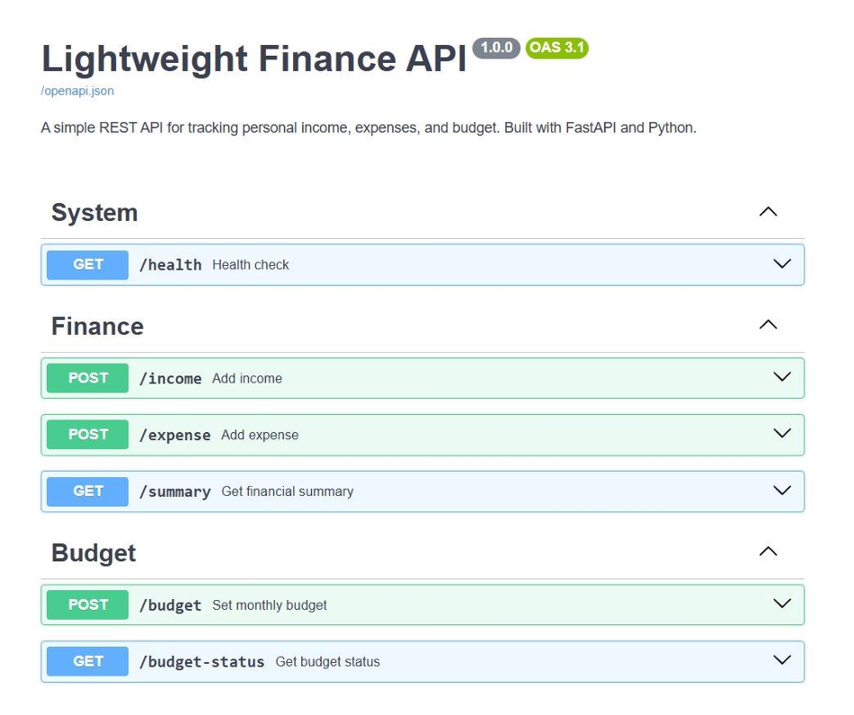

Snapshot 2 — Swagger UI schemas section

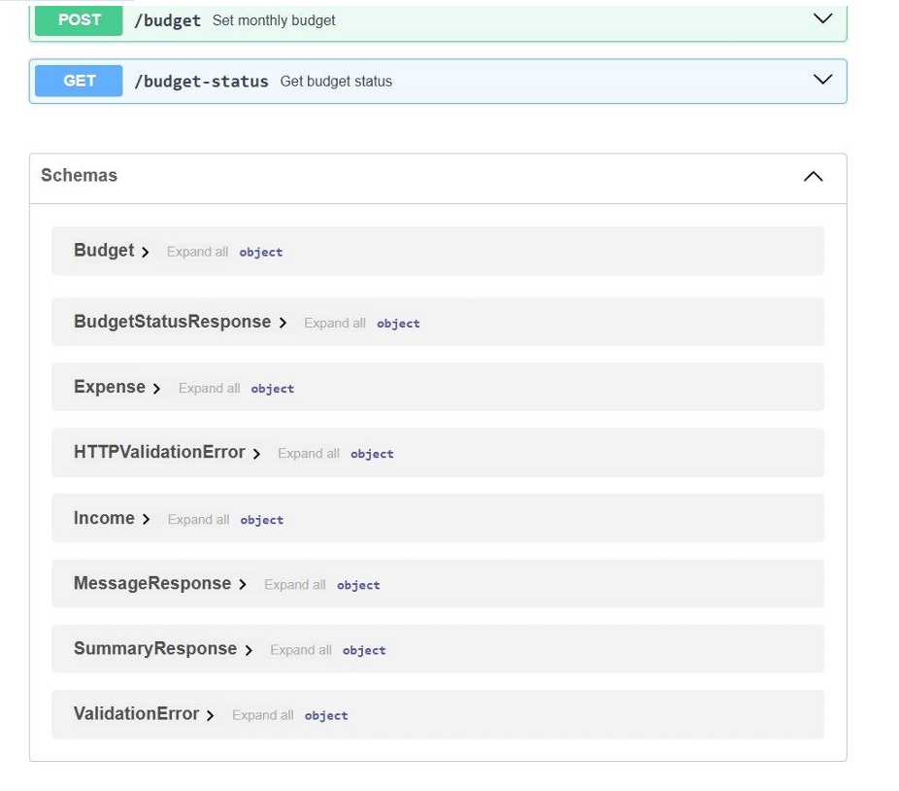

Snap shot 3 — Dashboard overview

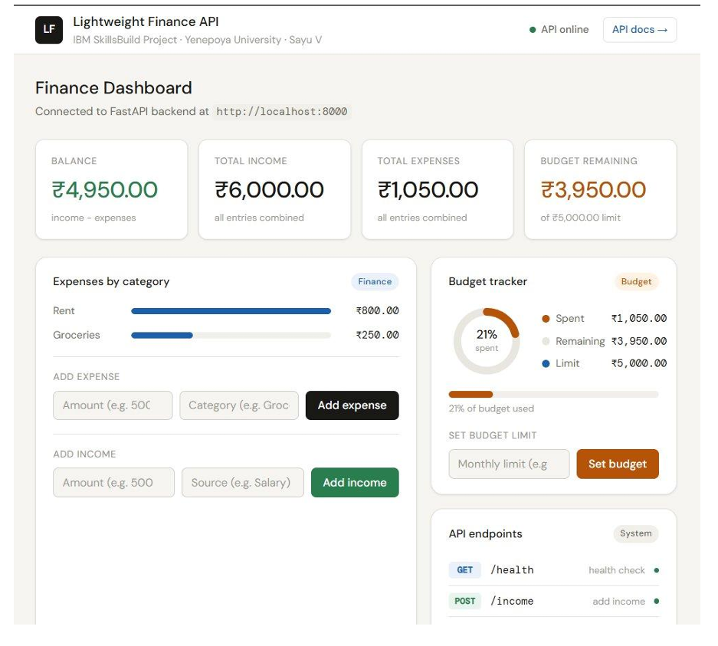

Snapshot 4 — Test suite, transactions, and project info

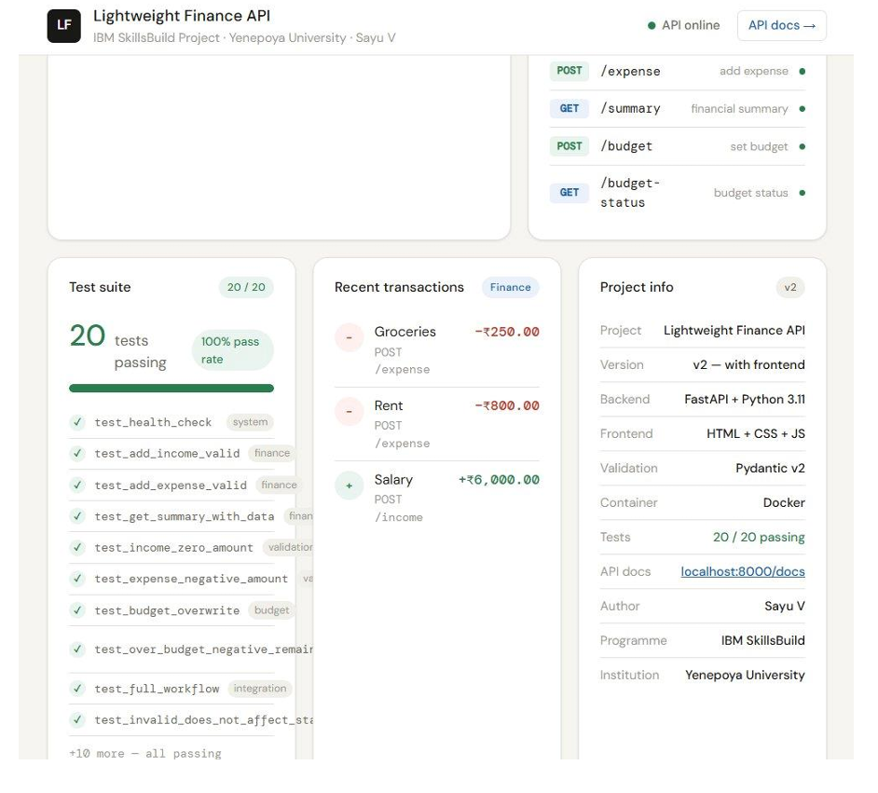

5. CONCLUSIONS

The Lightweight Finance API project successfully demonstrates the development of a simple, efficient, and cloud-ready backend system for managing basic financial operations such as income tracking, expense management, budget monitoring, and financial summary generation. The primary objective of the project was to build a lightweight API using Python and FastAPI that responds quickly to client requests while maintaining accuracy, reliability, and simplicity in design. This objective has been achieved through a well-structured implementation of RESTful API principles and modular backend design.

The system effectively handles all core functionalities including adding income and expense records, calculating financial summaries, managing budget values, and validating user inputs. The use of FastAPI enabled fast request processing, automatic API documentation, and efficient routing mechanisms. Input validation using Pydantic models ensured that only correct and structured data is processed, improving system reliability and reducing the chances of runtime errors.

The project also demonstrates proper backend development practices such as layered architecture, modular design, JSON-based communication, and in-memory data handling. Tools like Postman and Swagger UI were effectively used for testing and validating API endpoints, ensuring that each functionality works as expected under different scenarios. Additionally, containerization using Docker improved deployment consistency and portability across different environments.

From a learning perspective, the project helped in understanding key concepts of cloud computing workflows, REST API development, request-response cycles, and backend system design in a finance-related context. It also provided practical exposure to modern development tools such as GitHub, SourceTree, and VS Code, along with structured documentation practices.

Although the current implementation uses in-memory storage for simplicity, the system is designed in a modular way, allowing future enhancements such as database integration, user authentication, frontend development, and cloud deployment. These improvements can transform the current project into a full-fledged financial management application.

Overall, the Lightweight Finance API project is a successful implementation of a simple yet powerful backend system that fulfills its intended objectives. It demonstrates efficient API design, clean architecture, and practical application of backend development concepts in a real-world financial use case.

6. FURTHER DEVELOPMENT OR RESEARCH

The Lightweight Finance API project was developed as a simple and lightweight backend application for financial management and API processing. Although the current implementation successfully performs income tracking, expense management, budget monitoring, and financial summary generation, there are several opportunities for future enhancement and system expansion. These improvements can increase the functionality, scalability, security, and usability of the application.

One of the major future enhancements is database integration. The current system uses in-memory Python data structures for temporary data storage during application runtime. In future versions, relational databases such as MySQL or PostgreSQL can be integrated to provide permanent data storage, better data management, and improved scalability. Database integration would allow users to maintain long-term financial records and retrieve historical transaction data.

Another important improvement is user authentication and authorization. The current implementation does not include login or access control mechanisms. Future development can introduce secure authentication systems using JWT tokens or OAuth-based authentication methods. This would help protect user financial data and support multi-user access with role-based permissions.

The project can also be enhanced by developing a frontend graphical user interface using modern frontend frameworks such as React or Angular. A dedicated frontend dashboard would improve user interaction, data visualization, and overall user experience by allowing users to manage financial data through an interactive web interface instead of only using API testing tools.

Cloud deployment is another important area for future research and development. The application can be deployed on cloud platforms such as Amazon Web Services, Microsoft Azure, or Google Cloud to support scalability, remote accessibility, and cloud-native application management. Integration with CI/CD pipelines can further automate testing, deployment, and version management processes.

Additional financial features such as transaction history, expense categorization, monthly reports, analytics dashboards, savings recommendations, and notification systems can also be implemented in future versions. These features would improve the practical usability of the system and transform the project into a more advanced financial management platform.

Performance optimization and advanced API security mechanisms such as rate limiting, encryption, logging, and monitoring can also be explored as part of future research. These enhancements would improve system reliability, security, and enterprise-level readiness.

Overall, the Lightweight Finance API project provides a strong foundation for future expansion and research in backend API development, financial management systems, cloud computing, and modern web application technologies.

7. REFERENCES

- FastAPI Documentation https://fastapi.tiangolo.com

Pydantic v2 Documentation https://docs.pydantic.dev

Docker Documentation https://docs.docker.com

Python 3.11 Documentation https://docs.python.org/3.11

JetBrains Python Developers Survey(2023) https://www.jetbrains.com/lp/python- developers-survey-2023

IBM SkillsBuild Programme https://skillsbuild.org

GitHub Repository https://github.com/Sayu-V/Lightweight-Finance-API

8. APPENDIX

Appendix A — Document Suite Summary

DOC ID | DOCUMENT | FORMAT | KEY CONTENT
DOC-01 | Project Proposal | Word(.docx) | Project problem statement, objectives, methodology, project scope, development timeline, expected outcomes, and resource planning.
DOC-02 | PRD | Word(.docx) | Functional requirements, non-functional requirements, user stories, acceptance criteria, validation rules, and API behaviour specifications.
DOC-03 | HLD | Word(.docx) | Overall system architecture, layered design, component interactions, deployment architecture, cloud-readiness concepts, and data flow diagrams.
DOC-04 | LLD | Word(.docx) | Detailed endpoint contracts, request-response schemas, pseudocode, validation logic, error handling, sequence flows, and implementation details.
DOC-05 | API Reference Guide | Markdown(.md) | API endpoint documentation, HTTP methods, JSON request/response examples, curl commands, status codes, and error reference catalogue.
DOC-06 | Deployement Guide | Markdown(.md) | Local setup instructions, Docker configuration, container execution steps, dependency installation, troubleshooting guide, and environment configuration.
DOC-07 | Test Report | Markdown(.md) | Manual test cases, automated pytest execution results, validation testing, integration testing, edge-case analysis, and requirement coverage mapping.
DOC-08 | Final Project Report | Word(.docx) | Complete project lifecycle documentation including introduction, architecture, implementation, testing, evaluation, GUI snapshots, challenges, conclusions, and future enhancements.
DOC-09 | Presentation Deck | PowerPoint (.pptx) | Project presentation slides covering problem statement, objectives, architecture, implementation workflow, testing results, dashboard demonstration, and future scope
DOC-10 | Source Code Repository | GitHub Repository | FastAPI backend source code, frontend dashboard files, Docker configuration, test suite, project structure, and version-controlled implementation artifacts

— END OF DOCUMENT —

